# Game Design Document

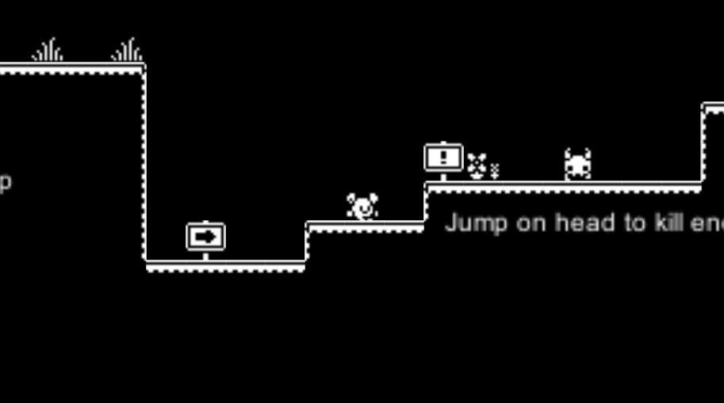

## **Game Objectives:**

This is a 1 bit style 2D jump game, similar to Super Mario in playing method. The player has the ability to jump on the enemy's head and trample the enemy to death. At the same time, the player is also very fragile, will be easily killed by the enemy, so the game must be careful to avoid the enemy. In addition, this is a horizontal version of the game, you need to run to the right inside the door to win.

**Genre:**

Adventure、Action

## **Design:**

The general idea of the game comes from Super Mario, which adopts the method of customs clearance. Players have a very simple operation mode: move and jump. Attacking the enemy is stepping on the enemy's head. In addition, it also removes some complicated elements of Super Mario, such as collecting gold coins. The goal of this game is very simple, customs clearance is OK, so players can use all possible means to clear customs, which is also the purpose of the game.

## **Controls:**

A: Move Left

D: Move Right

W: Jump

Jump on head to kill enemy

## **Bibliography:**

**Graph:**

menu, btn, credits by ChengSiming

monochrome_tilemap by kenney: https://kenney.nl/

**Audio**

Jump__001 & Ouch__001&Punch1__001 by phoenix1291: https://opengameart.org/content/sfx-the-ultimate-2017-8-bit-mini-pack

menu by Snabisch: https://opengameart.org/content/20-excellent-8-bit-loops

**Program**

by ChengSiming

## **Screenshots:**

